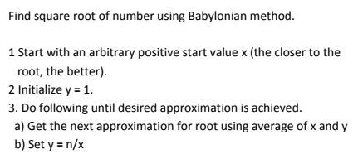

**Screenshot of code:-**

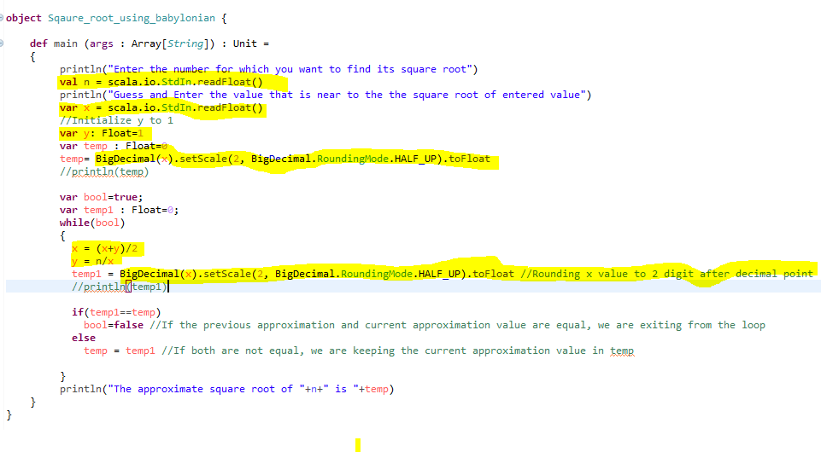

**SAMPLE OUTPUT 1:-**

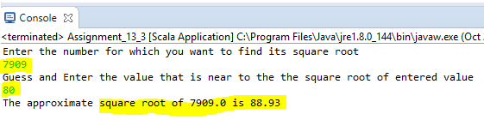

**SAMPLE OUTPUT 2:-**

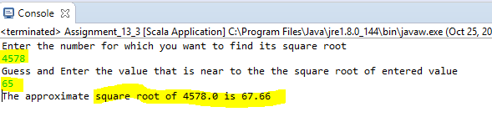

**PROBLEM CODE:-**

**object** Sqaure_root_using_babylonian {

**def** main (args : Array[*String*]) : Unit =

{

println("Enter the number for which you want to find its square root")

**val** n = scala.io.StdIn.readFloat()

println("Guess and Enter the value that is near to the the square root of entered value")

**var** x = scala.io.StdIn.readFloat()

//Initialize y to 1

**var** y: Float=1

**var** temp : Float=0

temp= BigDecimal(x).setScale(2, BigDecimal.RoundingMode.HALF_UP).toFloat

//println(temp)

**var** bool=**true**;

**var** temp1 : Float=0;

**while**(bool)

{

x = (x+y)/2

y = n/x

temp1 = BigDecimal(x).setScale(2, BigDecimal.RoundingMode.HALF_UP).toFloat //Rounding x value to 2 digit after decimal point

//println(temp1)

**if**(temp1==temp)

bool=**false** //If the previous approximation and current approximation value are equal, we are exiting from the loop

**else**

temp = temp1 //If both are not equal, we are keeping the current approximation value in temp

}

println("The approximate square root of "+n+" is "+temp)

}

}